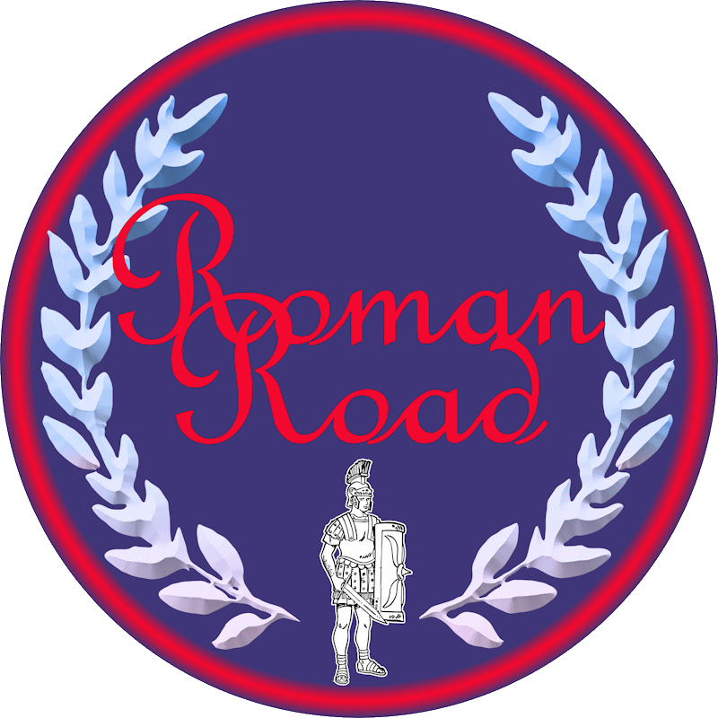
PSHE Curriculum 2026 - 2027
 | Autumn 1  6 lessons | Autumn 2  6 lessons | Spring 1  5 lessons | Spring 2  4 lessons | Summer 1  6 lessons | Summer 2  5 lessons
Y1 | Me and My Relationships | Valuing Differences | Keeping Safe | Rights and Respect | Being My Best | Growing and Changing
Y2 | Me and My Relationships | Valuing Differences | Keeping Safe | Rights and Respect | Being My Best | Growing and Changing
Y3 | Me and My Relationships | Valuing Differences | Keeping Safe | Rights and Respect | Being My Best | Growing and Changing
Y4 | Me and My Relationships | Valuing Differences | Keeping Safe | Rights and Respect | Being My Best | Growing and Changing
Y5 | Me and My Relationships | Valuing Differences | Keeping Safe | Rights and Respect | Being My Best | Growing and Changing
Y6 | Me and My Relationships | Valuing Differences | Keeping Safe | Rights and Respect | Being My Best | Growing and Changing

